**Composer:** It is a package manager for php (similar to **NPM**). We need to install this for working with Laravel. Composer needs php, so we need to install the minimum required version of PHP.

* To check if composer install, we can write in cmd **composer -V**
* To create a new Laravel application, we can use command **composer** **create-project laravel/laravel app-name-here**
* To serve the application locally by using the artisan server (built in the Laravel) we can use command **php artisan serve**

**Folder Structure:**

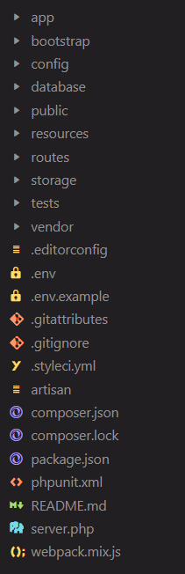

* **App:** This contains the core code of our application.
* **Bootstrap:** This contains files to bootstrap the framework itself, we don’t need to modify it normally.
* **Config:** This contains all config file. Its good idea to read through all files.
* **Database:** It contains your database migrations, model factories, and seeds. We may also use this directory to hold an SQLite database.
* **Public:** The public directory contains the **index.php** file, which is the entry point for all requests entering your application and configures autoloading. This directory also houses your assets such as images, JavaScript, and CSS.
* **Resources:** Contains views and un-compiled assets like CSS, JavaScript and images. It also contains language files (similar concept like android development)
* **Routes:** This contains definition of routes. Details in the official doc page.
* **Storage:** The storage directory contains your logs, compiled Blade templates, file-based sessions, file caches, and other files generated by the framework.
* **Tests:** Automated tests here
* **Vendor:** here composer dependencies are stored
* **.env:** Environmental variables are stored here.